Dice Games – Parent Session at Oakwood

On Thursday 20th October we invited parents to come into school to find out about number fluency. Over 60 parents or carers came to find out about approaches to teaching number fluency at Oakwood.

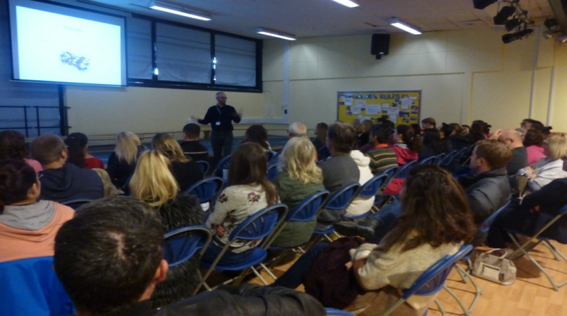
Mr Kelleher started the morning with a short presentation about having the right mind set to approach mathematics learning. We showed how practical activities like dice games can be used at home to support number fluency
Do you have a growth mindset?

Efficency implies that children do not get bogged down in too many steps or lose track of the logic of the strategy. An efficient strategy is one that children can carry out easily, keeping track of sub-problems and making use of intermediate results to solve the problem.

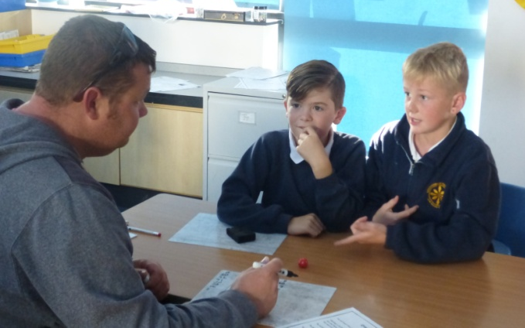
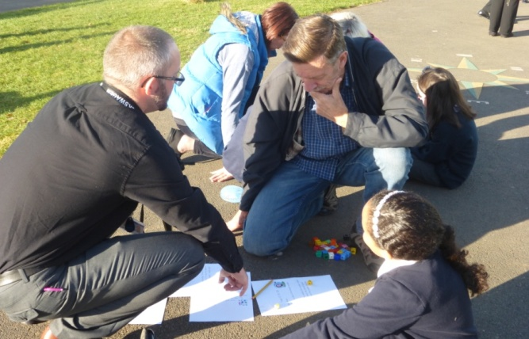
Accuracy depends on several aspects of the problem-solving process, among them careful recording, knowledge of number facts and other important number relationships and double-checking results.

Flexibility requires the knowledge of more than one approach to solving a particular kind of problem, such as two-digit multiplication. Children need to be flexible in order to choose an appropriate strategy for the numbers involved, and also be able to use one method to solve a problem and another method to check the results.
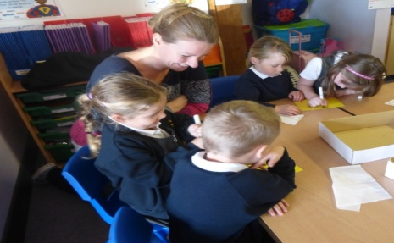
Go to the Maths page on our website for more news and information about Mathematics at Oakwood. Thank you for your support.

